Abstract Remote Model - v0.1

The biggest problem with PC remote control applications for the end-user is the configuration process. They generally fall into one of two categories. The first category is the “easy to setup but inflexible” category, and the second is the “difficult to setup but highly flexible” category.

Case in point: HIP vs Girder.

HIP is easy to setup without any prior knowledge, but HIP is not as feature rich or flexible as Girder.

Girder on the other hand is very difficult to setup compared to HIP, it has a steep learning curve, but is feature rich and flexible.

This document does not seek to make a value judgement on either application. Both are with their advantages and disadvantages.

The goal in software development is to produce a program that is easy to use but also powerful enough to be adapted to any situation.

The solution for PC Remote Control software to the traditional trade-off between usability and power is the subject of this document, the Abstract Remote Model.

By agreeing on the most common remote buttons and including a collection of mapping files to make all the supported remotes fit the common model we can provide a default configuration that will work on all supported remotes with no setup required. Default configurations would be supplied for a large number of common PC applications, as well as general OS navigation.

The drawback with other simplified systems of this nature is that you lose the flexibility to define different buttons and functions outside the simplified model, but with the system proposed any remote button that is not mapped onto the Abstract Remote Model will be passed on in it’s raw form, thereby enabling the user to customize beyond the default configuration.

This document will outline the usage details of the Abstract Remote Model in so far as it directly relates to improving the IR Server Suite.
Here we see a working example of the Abstract Remote Model in use …

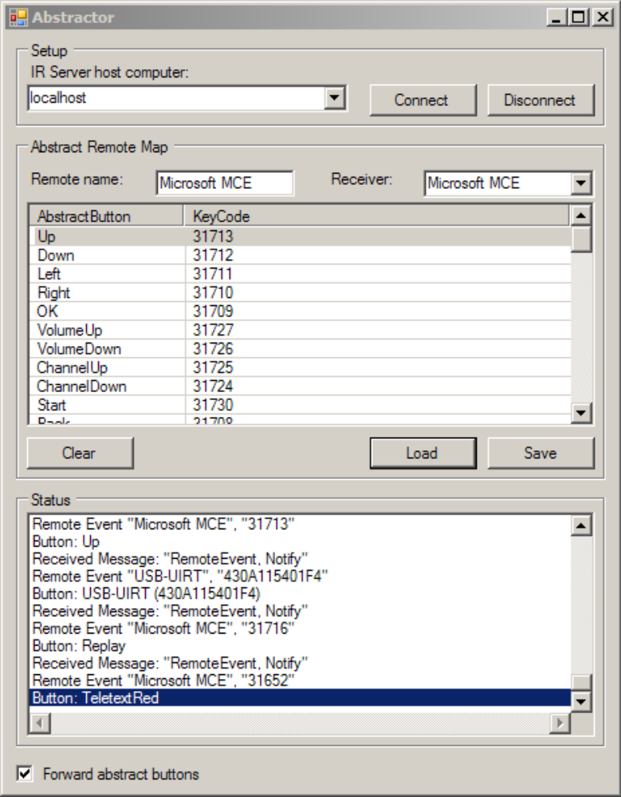

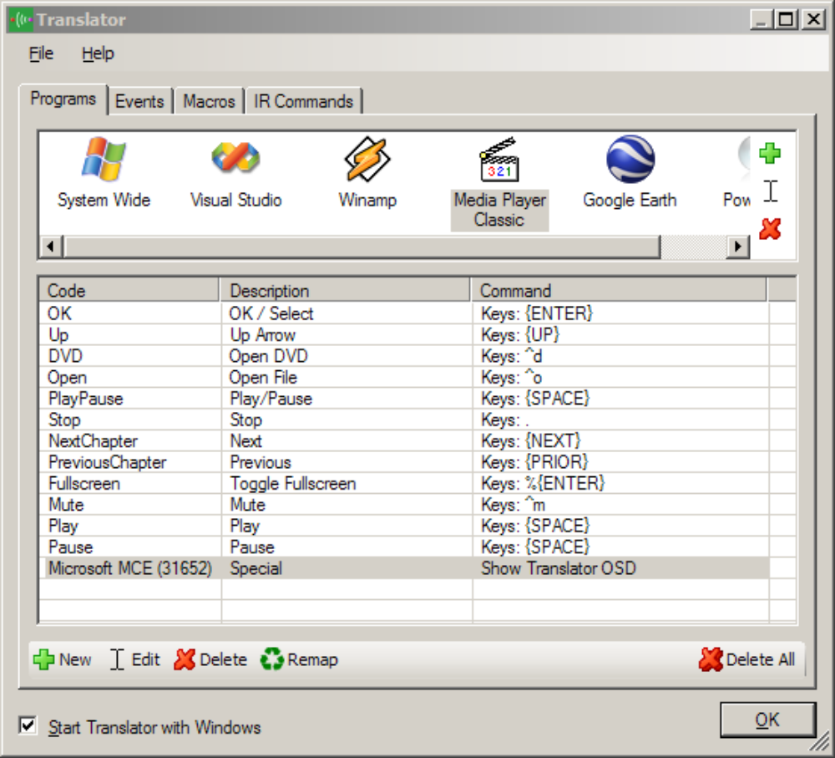
Notice the “Code” column above is showing Abstract buttons for all but the last entry. The last entry was not recognised by the “Abstractor” (left) and so the raw code was passed on to let the user retain full flexibility in the button mapping process.

For development and testing purposes the “button abstraction process” is being performed by the “Abstractor” program, but this functionality will be combined into the Input Service. Once the “abstraction” function is combined into the Input Service the Abstractor programs other function would be fully developed.

The “Abstract Remote Map” group box on the Abstractor main window is used to create remote maps that convert raw button codes to “Abstract Buttons”.

What follows is a list of remote buttons to include in the first draft specification of the Abstract Remote Model. Please add, remove or modify as you see fit and we can discuss the final composition of the button list.

Abstract Button Name | Brief description | Explanation
Up | Up Arrow | A feature of almost all PC remote controls, the arrow buttons are generally used to control the on screen cursor or item selection.
Down | Down Arrow
Left | Left Arrow
Right | Right Arrow
OK | OK / Select | Used to make a selection.
VolumeUp | Increase Volume | Increase the system or application volume.
VolumeDown | Decrease Volume | Decrease the system or application volume.
ChannelUp | Channel Up | In TV systems this button is used to increment the channel.
ChannelDown | Channel Down | In TV systems this button is used to decrement the channel.
Start | Start / Home / Go | This button may appear under many labels, in MCE convention it is referred to as the Start button and is used to launch a common application or while in that application it is also used to return to the main menu or home screen.
Back | Back | Often mapped as the keyboard Escape key, this buttons most common function is to leave a menu or abort an operation or selection.
Info | Info / More
Mute | Mute Volume | Mute either the system or application volume.
Number0 | 0 | Numbers from 0 through to 9 are used as either simple numerical text input, as channel number entry, or as an “sms-style” alpha-numeric text entry system.
Number1 | 1
Number2 | 2
Number3 | 3
Number4 | 4
Number5 | 5
Number6 | 6
Number7 | 7
Number8 | 8
Number9 | 9
Play | Play | Used to commence playback.
Pause | Pause | Used to pause playback.
PlayPause | Play / Pause | Many remotes will combine play and pause functions into one button that pauses when playback is already running and commences playback when it is not.
Stop | Stop | Stop playback.
FastForward | Fast Forward | Increase the playback rate.
Rewind | Rewind | Reverse the playback and increase the rate.
Record | Record | Record.
NextChapter | Chapter + | Skip to the next chapter or item in a playlist, can also be used as a Page Up or Down
PreviousChapter | Chapter - | Skip back to the previous chapter or item in a playlist, can also be used as a Page Up or Down.
Power | Power (Software) | Power button. For this purpose we will assume it refers to the running software.
Power2 | Power (PC) | Second Power button. For this purpose we will assume it always refers to the PCs power state.
Power3 | Power (Other) | Third Power button. User definable. Remove?
Teletext | Teletext | Turns Teletext (or can be subtitles) on or off.
TeletextRed | Red | When used in a teletext system these buttons each serve a purpose, however in systems or situations that do not have teletext these buttons can be given user-defined functions.
TeletextGreen | Green
TeletextYellow | Yellow
TeletextBlue | Blue
Subtitles | Subtitles | Toggle or Cycle subtitles.
Menu | Menu | Go to Menu (often DVD Menu).
Clear | Clear / Delete | Clear a text entry or delete a single character (backspace).
Enter | Enter | Simulates a keyboard Enter button press, or is used to add a carriage return to a block of text, where as pressing OK/Select would finish the text entry mode.
Hash | # | Used for special functions in alpha-numeric text entry modes. Or simply as a special character.
Star | *
TaskSwap | Task Swap / Alt-Tab | Used to switch between running applications on the PC.
Fullscreen | Toggle Fullscreen | Toggle video playback or window size between fullscreen and windowed.
AspectRatio | Toggle Aspect Ratio | Cycle the video aspect ratio between available values.
Setup | Setup | Setup. General configuration button.
Music | Music | Go to the Music section of a program, or used to launch a music application.
Pictures | Pictures | Go to the Pictures section of a program, or used to launch a picture viewer application.
Videos | Videos | Go to the Videos section of a program, or used to launch a video player application.
DVD | DVD | Go to the DVD section of a program, or used to launch a DVD player application.
TV | Television | Go to the Television section of a program, or used to launch a television application.
Guide | Guide / EPG | Go to the Guide or EPG section of a program.
LiveTV | Live TV | Go to the Live TV section of a program, or used to launch a live TV application.
Radio | Radio | Go to the Radio section of a program, or used to launch a radio application.
Print | Print | Print the current view.
Snapshot | Create Snapshot | Create an image file snapshot of the current view.
Open | Open | Open a file/program.
Close | Close | Close a file/program.
Eject | Eject | Eject a CD/DVD.
ScrollUp | Scroll Up | Scroll the view up.
ScrollDown | Scroll Down | Scroll the view down.
PageUp | Page Up | Page Up.
PageDown | Page Down | Page Down.

